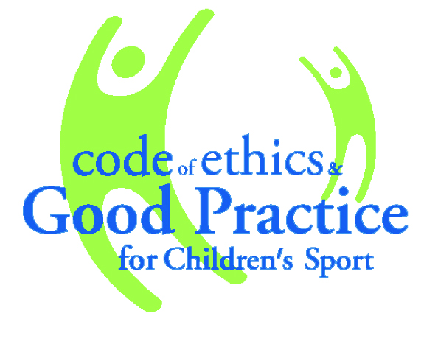
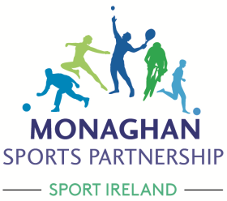
SAFEGUARDING in SPORT
  - INFORMATION LEAFLET
FOR SPORTS CLUBS & ORGANISATIONS

In 2015, The Irish Sports Council (now known as Sport Ireland) introduced a new structure to Child Welfare & Protection (Code of Ethics) workshops for Clubs. The details of the three stages of training are outlined here as follows:

Safeguarding 1 – Child Welfare & Protection Basic Awareness Course
All Coaches, Children’s Officers and Designated Liaison Persons (DLP) must first complete the 3 hour Child Welfare & Protection Basic Awareness Course. This course educates participants on the implementation of best practice in protecting the welfare of children involved in sport.

*Courses are available on an ongoing basis provided by Monaghan Sports Partnership or contact your relevant National Governing Body of Sport (NGB)

Safeguarding 2 – Club Children’s Officer (C.C.O.)
A person appointed to the Club Children’s Officer position in a club must have completed Safeguarding 1 (Child Welfare & Protection Basic Awareness workshop) and should complete the Safeguarding 2 (Club Children’s Officer) 3 hour workshop. This course will help the Club Children’s Officer to carry out the function of their role in the club and support the implementation of best practice in the club. Participants will also receive a Club Children’s Officer Action Planning document as part of the training.

Club Children's Officers
Club Children's Officers should be child centred in focus and have as the primary aim the establishment of a child centred ethos within the club. S/he is the link between the children and the adults in the club. S/he also takes responsibility for monitoring and reporting to the Club Management Committee on how club policy impacts on young people and Sports Leaders.

Safeguarding 3 - Designated Liaison Person (D.L.P.)
A person appointed to the Designated Liaison Person position in a club must have completed the Child Welfare & Protection Basic Awareness Course and should complete the Safeguarding 3 (Designated Liaison Person) 3 hour workshop. A club may appoint the same person to both the CCO and DLP positions however best practice advises that they are kept as separate roles.

Designated Liaison Person

Every club/organisation should designate a person to be responsible for dealing with any concerns about the protection of children. The Designated Liaison Person is responsible for reporting allegations or suspicions of child abuse to TULSA Child and Family Agency or Social Services (NI) and/or An Garda Siochán / PSNI. It is recommended that this person is a senior club person. However, if there is difficulty identifying a separate individual to take this role, the Club Children’s Officer can be appointed as Designated Liaison Person once the club/organisation is clear about the responsibilities of each role. The organisation’s child protection policy and procedures should include the name and contact details of the Designated Liaison Person and the responsibilities attached to the role.

Monaghan Sports Partnership regularly organises these workshops for sports club volunteers.

Our schedule of workshops for the remainder of the year 2017 is as follows:

Course | Date | Time | Course fee
Safeguarding 1 | Wednesday 27th September | 6.30pm – 9.30pm | €15
 | Thursday 12th October | 6.30pm – 9.30pm | €15
 | Wednesday 1st November | 6.30pm – 9.30pm | €15
Safeguarding 2 | Wednesday 22nd November | 6.30pm – 9.30pm | €15
Safeguarding 3 | Monday 27th November | 6.30pm – 9.30pm | €15

Venue: All courses take place at Castleblayney Enterprise Centre, Dublin Road, Castleblayney
Time: All courses run from 6.30pm – 9.30pm (sharp)

Booking information – all courses must be booked in advance through our office as we do not accommodate registrations on the evening of the course.
Interested persons should be members of an official sports club which is affiliated with a National Governing Body of Sport.

Participants receive a certificate of attendance and are registered with Sport Ireland as having attended these workshops.

*Should minimum numbers not be achieved for nay course, Monaghan Sports Partnership reserves the right to cancel the course and offer and alternative date (where available) to interested persons

Safeguarding for Sports Clubs
Monaghan Sports Partnership has also facilitated a number of Safeguarding workshops directly with local Clubs. If you have 15 volunteers who require Safeguarding 1 training, we can arrange this course at your Club venue*. This is a good way for clubs to emphasise the importance of Safeguarding in sport and to ensure that all club volunteers are aware of their own personal responsibility as a mentor within Children’s sport.
Safeguarding is for the entire club – committee members, coaches, managers, leaders, assistants, parents – and is the responsibility of everyone involved in children’s sport.

For more information please contact Monaghan Sports Partnership at 042-9755126

*Terms & Conditions apply

