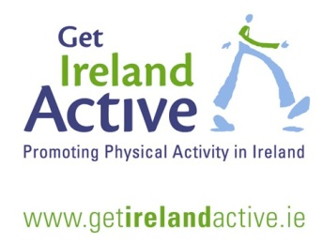
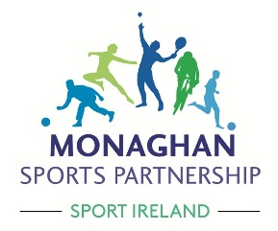

COMMUNITY TRANSFORMATION PROGRAMME INFORMATION

Monaghan Sports Partnership is delighted to introduce a new community-based programme which aims to support communities in creating opportunities for fitter, healthier lifestyles for everybody.

The concept is for communities to work together to provide a plan of physical activities in their town / village between 14th January & 10th March 2019 By joining together and making best use of facilities and volunteers, communities are best placed to co-ordinate accessible and low cost physical activity sessions.

The activities:
Communities choose the physical activity sessions they want to deliver; some examples may be:
1) Pilates; Yoga; Circuit Training; Tai Chi; Aerobics; Line dancing etc.
2) Local sports clubs and their activities for new members e.g. Golf, bowls, cycling, tennis etc.
3) Free activities may include, walk/jog sessions, buggy pushes, running programmes, using outdoor gyms and outdoor sports areas.

Think of all people in your community and the types of activities that may be suitable to them, and the activities which can cater for the greater numbers

The partnership approach:
Community based programmes designed for the whole community work best when delivered in partnership.
Community partnerships could consist of two or more of the following:
- Sports Club
- Primary School / Parents Association
- Secondary School / Parents Association
- Community Development Association
- Disability Groups
- Childcare Groups
- Women’s Groups
- Older Adults Groups
- Any other local group
What the community does?
- Community Transformation areas will consist of a minimum of 2 community partners;
- Each community will nominate a ‘community transformation’ coordinator who will be the contact person for the programme;
- The coordinator is responsible for paying programme costs;
- The community must also provide the venue– this must be suitable for exercise classes for 20 people at a minimum. (options of outdoor sessions are acceptable);
- Each community plan must include a minimum of three physical activity sessions per week and one of these should be a walk / jog programme (eg couch to 5km);
- The community will advertise the programme locally (posters, club notice board etc), take registration for the programme and make sure the venue is opened/closed and suitable for the sessions.
- The Community will agree to host a local ‘Operation Transformation’ Walk on Saturday 12th January 2019 at 10.am and may use this event to promote the transformation programme and recruit participants
- The Community will agree to organise a local 5km walk / jog at the end of the programme as a celebratory event and as a benchmark to showcase improvement in fitness levels

What will the sports partnership provide?
- €500 per community towards the costs for the physical activity programmes;
- A community transformation starter pack to include
  - Registration sheets
  - Materials to promote your transformation programme
  - High Vis materials for your group
  - Couch to 5km walk/jog plan and support pack
  - Assistance, if necessary, in sourcing an activity and instructor for sessions;
  - Assistance with advertising the programme and provide each club with posters and flyers to advertise their programme locally;
  - We will link in with the local coordinator throughout the programme to ensure the programme is meeting the needs of the participants.

Who is the programme for?
The programme is for the whole community. The programme aims to provide a fun environment for all people in the area to meet and get fit together while trying out some new activities!
How much will the programme cost to participants?
The community decides this. (we have a suggested maximum charge)
What you charge depends on how many classes you have available and your venue costs. This programme is subsidised by Monaghan Sports Partnership. This support will ensure low cost fees for all participants.

What next?
If your community is interested in taking part, please fill out the expression of interest form and return (via post/email) to the Monaghan Sports Partnership office by Friday 7th December 2018
No late applications will be accepted

For this round of the programme we can only accommodate 3 communities. Those who have planned their schedule of activity and deemed ‘ready to start’ may be given preference. Once expression of interest forms are received, we will contact the Contact Person for this application and / or the Community Transformation Coordinator.

For more information or queries, please call Monaghan Sports Partnership on 042-9755126 or email info@monaghansports.ie

