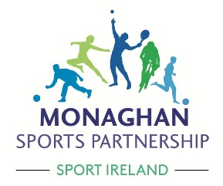

Community Transformation Programme
Invitation to Local Communities
Would your community like to work with Monaghan Sports Partnership in supporting a physical activity programme in your local area?

Does your community have the capacity to come together to provide a range of physical activity opportunities for everyone?

Would your community like run a programme which develops fitter, healthier, happier people?

If you think this is for your community in 2019, please contact
Monaghan Sports Partnership to find out more.

Expression of Interest and additional information is available at;
www.monaghansports.ie or
by email to info@monaghansports.ie or by phone to: 042-9755126

CLOSING DATE FOR APPLICATIONS - DECEMBER 7TH

(Communities must have the capacity to start 8-week activity programme in January 2019)
Please note the number of communities that can be supported is limited.

