MONAGHAN SPORTS PARTNERSHIP

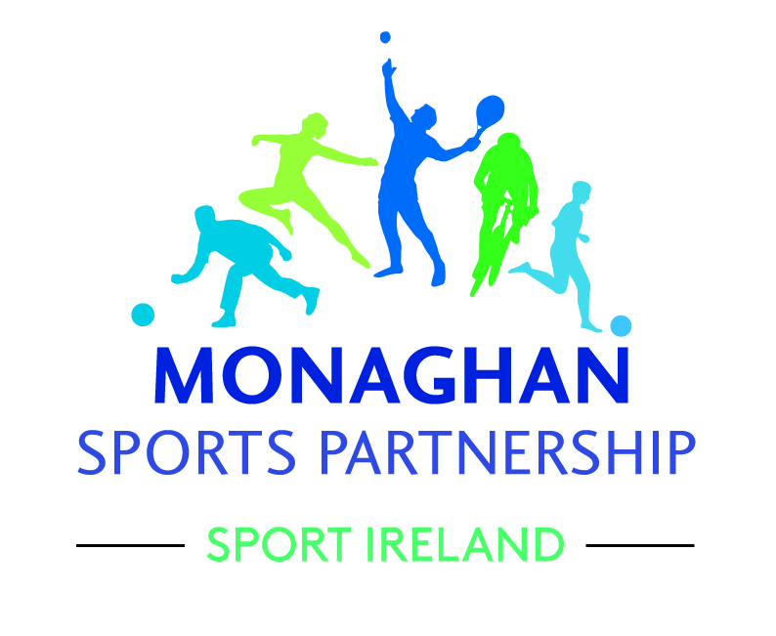

Request for tenders for

STRATEGIC PLANNING PROCESS

Development of the
Monaghan Sports Partnership
Strategic Plan 2017 – 2021
(including review of previous plan)

Strategic Planning Process

Requirements
The consultant will facilitate all aspects of the review of the previous plan, the preparation and development of a new comprehensive and concise strategic plan for 2017-2021 including the writing of same to final stage.

Background
Monaghan Sports Partnership (MSP) was established in 2006 following a successful bid to Sport Ireland. The key aims of the Local Sports Partnership is to increase participation in sport through coordination ensuring that local resources are used to best effect. Monaghan Sports Partnership aims to enable the ongoing development of quality sporting and active recreational opportunities
throughout County Monaghan in an environment that promotes healthy lifestyles, maximum participation and achievement.

The outcomes sought from the Local Sports Partnerships by Sport Ireland include:
- Enhanced planning of sport at local level
- Increased levels of local participation, especially amongst specific target groups such as older people, girls and women, people with disabilities, unemployed people and those who live in identified disadvantaged communities
- Club Development & Volunteer training
- Local directories of sports bodies and facilities
- Clear priorities for facility provision and improvement, with related quality
- management initiatives
- School/ club/ community and school/ National Governing Body links
- Local Sports events

Monaghan LSP is supported in its work by a Board of Management with a broad spectrum of representative groups on the board including sports clubs, community / voluntary groups and statutory bodies. Monaghan Sports Partnership employs a Sports Co-ordinator, Sports Administrator, a Community Sports Development Officer and a Sports Inclusion Development Officer (on a shared basis with Cavan LSP) whose posts are funded by Sport Ireland and Monaghan County Council.

The previous plan identified four strategic themes:
1) Increasing Participation;
2) Developing Sports Clubs and Organisations
3) Communications and Information;
4) Building the Organisation;

Tasks in the development of the Strategic Plan 2017-2021 to be completed by consultant:
A review of the previous plan to outline:
- The changing context in which the Local Sports Partnership has worked to date (and the context against which the next strategic plan will be developed)
- Achievements and shortcomings under each of the four strategic themes identified in the first plan (these to be both qualitative and quantitative)
- A summary of how delivery of the first plan has been viewed by staff, board members (and the agencies they represent) and key stakeholders such as sports clubs, representatives of target groups identified for interventions etc
- A summary of learning from the review
- A proposed set of priority themes with broad objectives and actions (set out in order of priority) for the new strategic plan of the Local Sports Partnership.
- Any additional recommendations that the external reviewer wishes to make

- Consultation with the Sports Co-ordinator in the form of 3 face to face meetings and as necessary, email and telephone communication.
- Board development and planning workshop (3 hours) with the MSP Board of Management involving debate on vision, mission, goals, objectives and key issues for sport and recreation.
- One to one meetings with MSP Chairperson, Monaghan County Council and Sport Ireland;
- Three Public consultation meetings to be conducted in the evening time at various locations in the County
- Consultations to be conducted with key agencies during working hours. (key agencies to include; HSE, ETB, Local Development Companies, Primary & Secondary Schools, Third level college, Sporting RDO’s, Community Development Workers.)
- Draft framework document developed
- Write up of final strategy taking into account feedback and suggested changes from MSP.

The final plan should be presented to a high standard of quality which meets the requirements of Sport Ireland and its Strategic Planning guidelines and must be comprehensive in its assessment of:
- The current standing of Monaghan Sports Partnership in the Community
- The Internal Environment
- The External Environment
- SWOT Analysis
- The Vision, Mission Statement, key thematic areas and objectives

Approach:
- Build on existing data and consider current and future strategy in the context of relevant plans/strategies eg. Sport Ireland Strategy/SPEAK, Monaghan County Council LECP, National Physical Activity Plan, Irish Sports Monitor etc.
- Quantitative and Qualitative data from feedback from stakeholders and consultations and interviews and focus groups.
- The successful consultant will have responsibility for driving the initiative which will draw on their necessary expertise and knowledge and will be expected to make recommendations and draw conclusions as appropriate

Timeframe:
The closing date for receiving proposals is Friday 7th July 2017 (5.00pm)
It is anticipated that the board of management will have selected a candidate within one week of this date and an agreed start / completion date confirmed.

Responses must include:
- Process/ timetable listing key milestones (for reporting progress on various stages of development) and dates for meeting the deadline
- Methodology to be used
- Description of expertise and experience (including team members, if relevant)
- Detailed budget
- Breakdown of time allocations
- Identification of any conflicts of interest
- Referee: contact details must be supplied for 2 referees’ that the management group can contact who has used the proposed consultant for similar/ related work and two examples of similar work carried out (reference or provide two plans produced)

Budget:
The budget available for the total project will be no more than €4500 (Including VAT and expenses)
Please outline clearly all fees. A current tax clearance certificate will be required. This contract will be awarded on the basis of a fixed price contract, and as such, all costs must be quoted (and clearly indicated) as a fixed price in Euro. The successful consultant is expected to work within the agreed budget and report regularly on budgetary issues. Consideration will be given to competitive tenders.

Insurance:
The successful consultant will be required to submit evidence of relevant professional indemnity and insurance details.

Lodging a Tender:
- Consultants responding to this brief are required to nominate a lead person from their organisation as a point of contact.
- Consultants are required to provide details of all key staff and experience in the provision of these services (where applicable)
- Late proposals will not be considered.
- All supporting material and documentation should be included in the response.
- All costs associated with the consultant’s response to the Request for Tender will be the responsibility of the consultant.
- Tender proposals may be lodged by post or email as per contact details below

Tender Acceptance:
- Monaghan Sports Partnership is not bound to accept the lowest or any tender and will award the contract to its best advantage.
- The successful tender must commit to completing the assignment on time and on budget
and failure to meet the timeline agreed may affect payment
- All unsuccessful tenders will also be advised of the decision.
- Unless otherwise expressly agreed, there shall be no binding contract between the tender and the MSP unless or until, a written contract is signed by both parties.

Monaghan Sports Partnership expressly reserves the right to:
- Extend the time of lodgement of responses to the Request for Tender and/ or to vary the timings and process for their Request for Tender.
- Vary any requirements of the services required for the Request for Tender.
- Following evaluation, accept or reject any or all responses to the Request for Tender.
- Seek and obtain clarification of any responses to the Request for Tender, including additional information.
- Request providers to amend their responses.
- Accept any proposal in part or in total.

Tender Evaluation Process:
Initially the tender proposals will be checked for compliance with the Request for Tender conditions. Potential consultants will be assessed both on their tender proposal and if required, a follow up interview. They will be assessed against the following major attributes:
- Proven capability and experience in research, consultation and relevant field of work (400)
- Methodology (300)
- Cost (300)
- Time - consideration given to timeline under which the work can be completed

*A minimum threshold of 100 in any one category will be necessary

Copyright and Confidentiality
The consultant will be required to assign copyright of the report to Monaghan Sports Partnership. Copyright for any illustrations or other material used should be cleared by the consultant. Sections of the report may be made available for public use by Monaghan Sports Partnership.

Freedom of Information
Monaghan Sports Partnership operates under the Freedom of Information Act 1997 and all information held by the Sports Partnership (including proposals submitted in response to this brief) may be subject to requests under the Act.

Contact:
Please return tender to the address below, with all queries directed to same:
Closing Date: Friday 7th July 2017 (5pm)
Michelle Murphy, Sports Coordinator, Monaghan Sports Partnership
c/o Ballybay Civic Centre, Main Street, Ballybay, Co. Monaghan
Tel No: 042-9755126
Email: mmurphy@monaghancococ.ie

